Test plan for
TrashTrekker :Smart Waste Mangaement System

ChangeLog

Version | Change Date | By | Description
version number | Date of Change | Name of person who made changes | Description of the changes made
001 | 10/31/2023 | Karnik Gautam | Initial Draft

1 Introduction 2
1.1 Scope 2
1.2 Quality Objective 2
1.3 Roles and Responsibilities 3
2 Test Methodology 3
2.1 Overview 3
2.2 Test Levels 3
2.3 Test Completeness 4
3 Test Deliverables 5
4 Resource & Environment Needs 6
4.1 Testing Tools 6
4.2 Test Environment 7
5 Terms/Acronyms 7

Introduction
Smart cities integrate multiple mobile or web solutions to build a comfortable human habitation.
Multiple mobile or online technologies are combined in smart cities to create a comfortable environment for people to live. Offering a waste management system that is efficient, effective, and ecologically beneficial is one of these alternatives. The existing garbage collection system involves routine garbage trucks making daily or weekly rounds, which is not only a grossly wasteful use of public resources but also doesn't reach every part of the city. The suggested approach, in which the admin operates the web app for complete online-based monitoring and system analysis. Bins, the driver, user complaints, and job updates from the driver are managed by her admin. The government can use the resources at its disposal to effectively manage the enormous volumes of rubbish that are picked up every day, and this paper offers a cost-effective mobile or web-based solution that will do both of these tasks. A more effective remedy for the inconvenience caused to the population by garbage disposal. A driver handles this an app will offer recommended and supervised routes for garbage trucks. Then after, the driver will change the status of the task that has now been completed. For the workforce and residents, an android or web app that mainly provides the user the ability to create complaints is provided in a smart bin.

Scope

Functional Requirements:
Data Acquisition: Obtain sensor readings from various sensor types in real-time.

Data Storage and Database: Store sensor data securely in a MySQL database for historical analysis.

Condition-Based Calculation: Identify bins with fill levels over 80% for prioritized garbage collection.

Live Monitoring: Provide a user-friendly client-side script for real-time monitoring of garbage collection status.

Non-functional Requirement:
Performance Testing: Verify system response times and scalability under varying loads, including stress testing.

Reliability Testing: Test system availability, recovery, and failover mechanisms.

Security Testing: Assess authentication, authorization, data encryption, and vulnerability assessments.
Usability Testing: Evaluate accessibility and user interface usability. Compatibility Testing: Ensure compatibility with different browsers, devices, and integration with external systems.

Compliance Testing: Verify regulatory compliance and assess environmental impact. Maintenance Testing: Evaluate update and upgrade processes and the accuracy of system documentation.

Data Backup and Recovery Testing: Test backup and restore procedures for data integrity.

Cost-Efficiency Testing: Assess operational cost efficiency. This condensed list still captures the essential non-functional requirements for your test plan while making it more concise and focused.

Quality Objective

The main objectives of our proposed system are as follows:
- Monitoring the garbage management.
- Providing a smart technology for garbage system.
- Reducing human time and effort .
- Resulting in healthy and waste ridden environment.

Roles and Responsibilities
Detail description of the Roles and responsibilities of different team members like
- QA Analyst : Karnik Gautam
- Test Manager : Mr. Abhishek Goyal
- Configuration Manager: Prof. Akankskha
- Developers: Harsh Yadav , Karan Agarwal
- Installation Team: Karnik Gautam , Harsh Yadav , Karan Agarwal

Test Methodology

Overview

Hybrid Methodology: When to Use: A hybrid approach can be effective when your project has a mix of well-defined and evolving requirements. You can combine aspects of both Agile and Waterfall to suit your project's unique needs. Advantages: This approach allows you to maintain a structured plan while accommodating changes and feedback as necessary. Considerations: Careful planning and coordination between phases are crucial to make the hybrid model work effectively.

Test Levels

Test Levels define the Types of Testing to be executed on the Application Under Test (AUT). The Testing Levels primarily depends on the scope of the project, time and budget constraints.

Performance Testing:
Response Time: Define acceptable response times for critical functions, such as retrieving sensor data or generating reports.
Scalability: Verify the system's performance under varying loads, including the ability to handle a larger number of sensors or simultaneous users.
Stress Testing: Assess the system's response under extreme conditions to ensure it can handle peak loads without critical failures.

Reliability Testing:
Availability: Specify the desired level of system uptime and test for reliability to minimize unplanned downtime.
Recovery Testing: Evaluate the system's ability to recover from failures or crashes without data loss or corruption.
Failover Testing: Verify that the system can smoothly transition to a backup or redundant system in case of a failure.

Security Testing:
Authentication and Authorization: Ensure that only authorized users have access to sensitive features and data.
Data Encryption: Verify that sensitive data is encrypted during transmission and storage to protect against unauthorized access.
Vulnerability Assessment: Regularly conduct security assessments, such as penetration testing, to identify and address potential vulnerabilities.

Usability Testing:
Accessibility: Confirm that the user interface is accessible to individuals with disabilities, including support for screen readers and keyboard navigation.
User Interface Testing: Assess the usability and user-friendliness of the application, considering user satisfaction and ease of use.

Compatibility Testing:
Browser and Device Compatibility: Ensure that the system functions correctly on various web browsers and devices, including mobile devices and different operating systems.
Integration Testing: Validate the system's ability to integrate with other software, databases, or external systems without conflicts.

Test Completeness
Here you define the criterias that will deem your testing complete.
For instance, a few criteria to check Test Completeness would be
- 100% test coverage
- All Manual & Automated Test cases executed
- All open bugs are fixed or will be fixed in next release

Test Deliverables
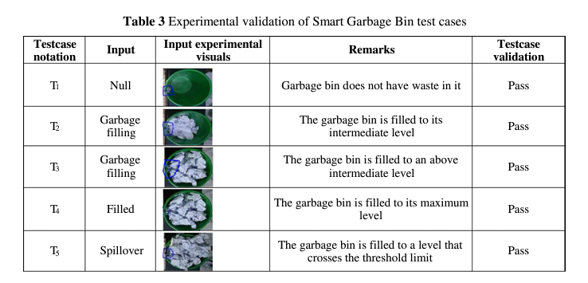
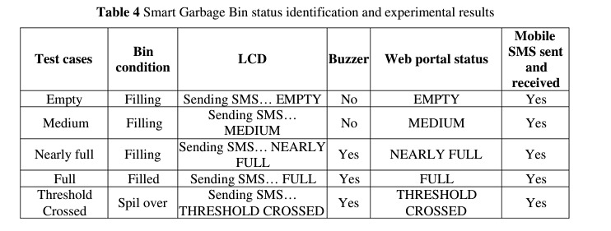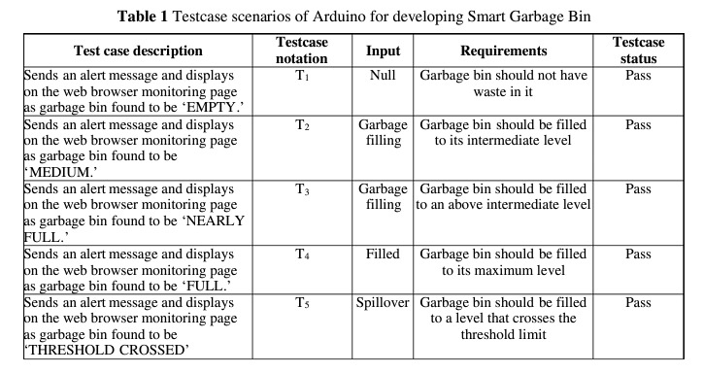
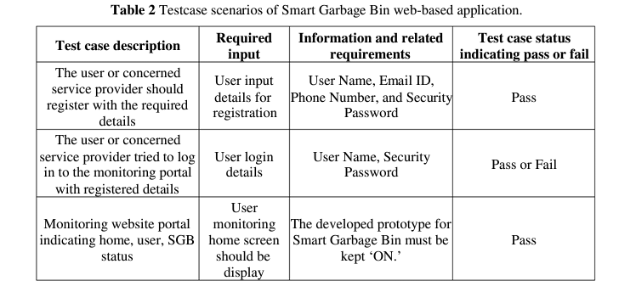

Login Page:
FAIL:
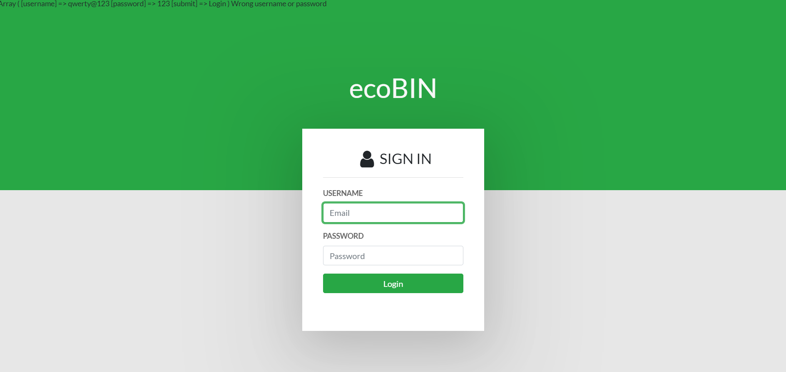

PASS:
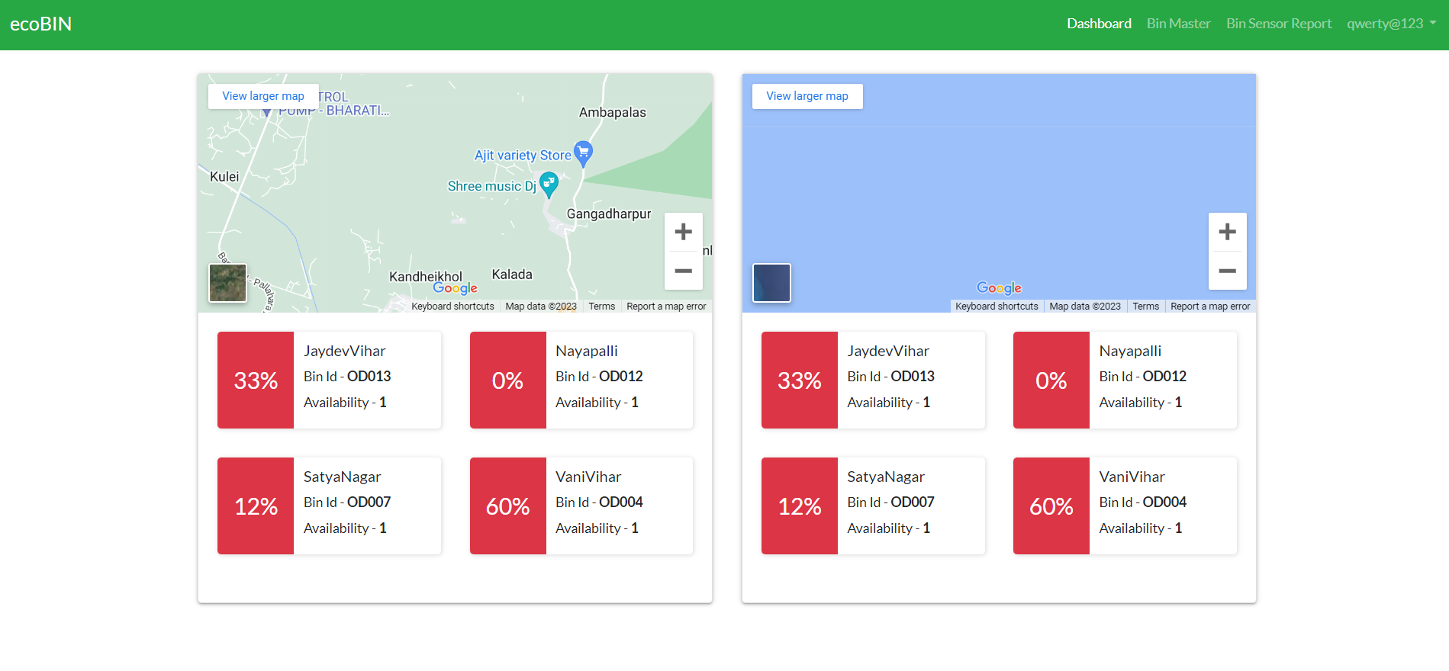

Resource & Environment Needs

Testing Tools

SQLUnit: A tool for database testing that allows you to define and run SQL-based tests on your database.

Selenium: A popular tool for automated functional testing of web applications, which can be useful for testing user interfaces in your system.

Jenkins: An open-source automation server that can be used for building, testing, and deploying code continuously.

Test Environment
It mentions the minimum hardware requirements that will be used to test the Application.

Following software’s are required in addition to client-specific software.

- Windows 8 and above
- Office 2013 and above
- MS Exchange, etc.

Terms/Acronyms
Make a mention of any terms or acronyms used in the project

TERM/ACRONYM | DEFINITION
API | Application Program Interface
AUT | Application Under Test

Test Report

For

TrashTrekker :Smart Waste Mangaement System
(Project Id: PCS24-32)

BACHELOR OF TECHNOLOGY
IN
COMPUTER SCIENCE



Session 2023-24

Dr. Gaurav Dubey Mr. Abhishek Goyal
(Project Guide) (Testing Lab Faculty)

Submitted by Submitted To:
Harsh Yadav (2000290120073) - 7B Prof. Neha Shukla
Karan Agrawal (2000290120082) – 7B Project Coordinator
Karnik Gautam (2000290120083) – 7B Dept. of Computer Science

